Roger Tran

3/17/18

Assignment 6: Written Description on 3 Observable Trends

Trend 1: Temperatures Drop North of Equator

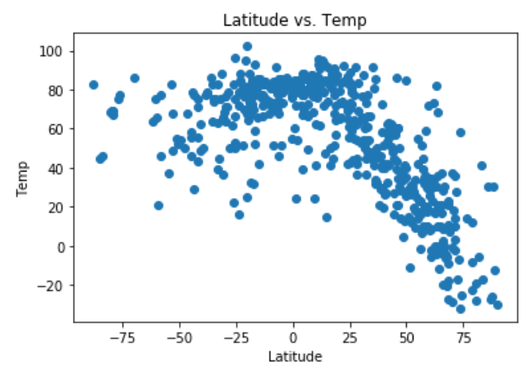

Temperatures are highest around the equator. They tend to drop as the observation looks at cities in the Northern hemisphere. The data suggests that temperature does not drop as we look at cities in the Southern hemisphere. A possible explanation is that there are fewer cities in the southern hemisphere so the distribution is not normal.

Trend 2: Cities near the equator are more humid

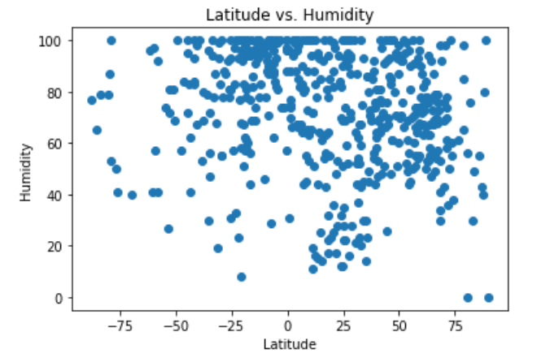



The densest cluster of cities that have the highest humidity are near the equator at latitudes -25 to 0. Cities north of the equator are less humid.

Trend 3: Latitude has little impact on wind speeds

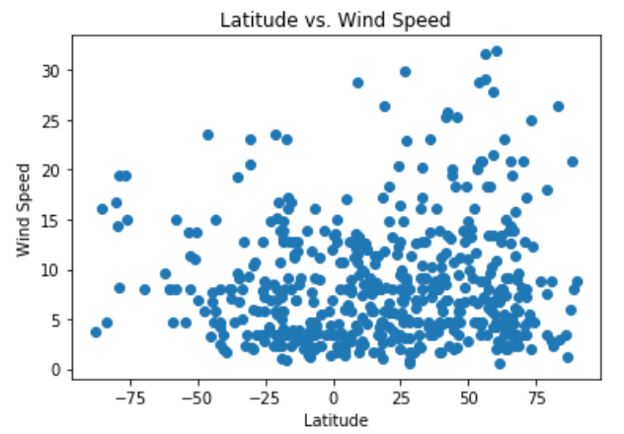

No real correlation between latitude and wind speed. Wind speeds vary at all latitudes. Most cities’ wind speeds are below 10 MPH.